# Santiago / Andes Mountains Trip Report

The team travelled deep into the Andes Mountains outside of Santiago to learn more about the records of pollution in the mountain range due to the population of Santiago.

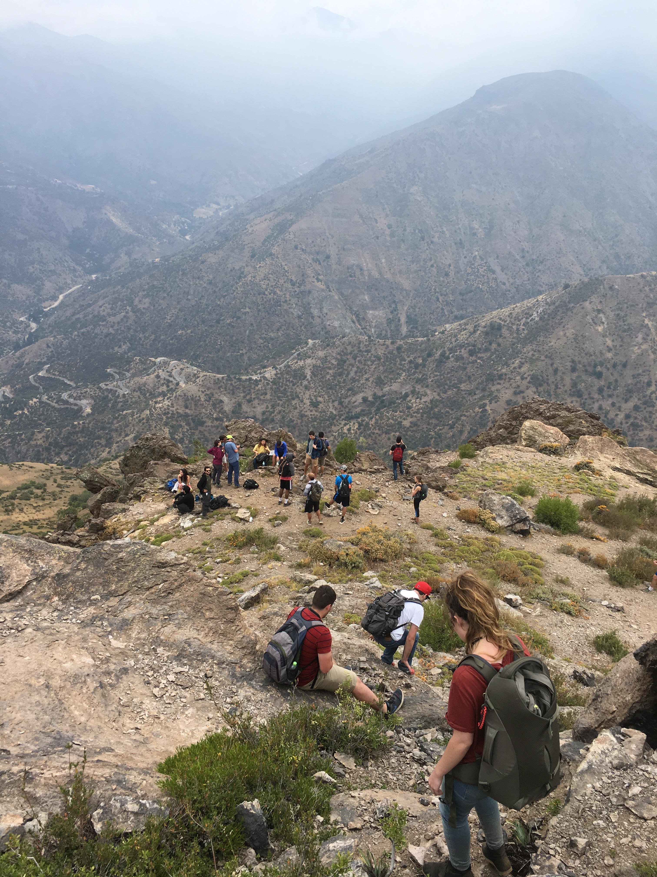

The team hiked up a trail for an hour to a set of radio towers where we received a few sheets of data that showed various graphs/charts showing the pollution found in the trees of the mountains. The data contained three pie charts showing changes in major pollutants from 1998-1999, 2003-2005, and 2011-2012. The charts showed an increase in chemicals from car exhaust (because of population growth), a decrease in copper particulate, and an increase in lead particulate. Lead was removed from gasoline in 1992, but the metal is still present in the atmosphere and on top of the soil since it is not able to percolate down into the soil. This change could be seen in the graphs as the increasing level of pollutants dropped considerably and continues to decrease with time. With these policies still in effect, the levels of pollutants in the atmosphere are still unacceptable and more changes need to be made. These levels are unacceptable, as there is a heavy smog across the mountains and blocking the view of Santiago from where the team hiked.

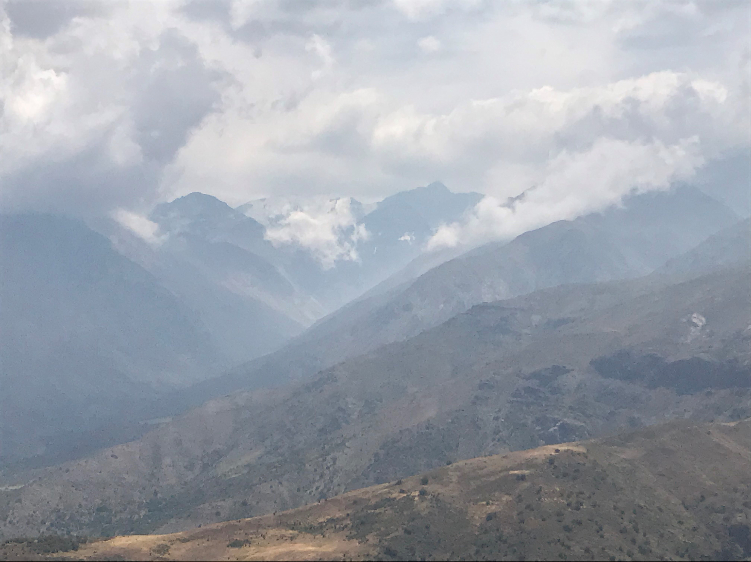

The ground has been extremely dry from the recent drought. Because of this, the prevailing winds blow-contaminated air from the city into the mountain range, so the impact/levels of the contaminated air is best represented by tree core samples. These samples have been used to compile a history of pollutant and rainfall data to be used to better inform politicians so that they may pass more environmentally friendly legislation.

While hiking back the team had the pleasure of seeing several Condors flying overhead. The Condor is the national bird of Chile and is a very large vulture that glides upon the breeze. The Condor can be seen below in Figure X.

